# **1. Project Title**

Soccer Matches Management System

# **2. Team**

Member 1 **Tarek Ahmed** (MySQL Expert)

Member 2 **Daniil Volovik** (MS SQL Server Expert)

# **3. Weekly Meeting Hours**

We will meet and work on the project every Tuesday from 3.30 pm to 4:30 pm, Friday from 11:30 am to 1 pm.

# **4. Project Description**

A database is created which records the information about many soccer teams, their members, the captain and coach of the team, the matches they participated, the result of the matches, the championships they received.

**Entities:**

**Player**, properties: name, DoB, number (marked on their shirt), picture, a role in each match (can be different from match to match), number of goals scored in each match.

**Coach**, *every team* has a couch, properties: name, DoB, start and end time of coaching, in which matches that person has been coach of the team.

**Match**: location, date, time, two teams that played (host, guest), the result of the match (e.g. 0-5, or 2-4, …).

**Championship**: date, the name of championship and the medal a team won (gold, silver…or 1st place, 2nd place…).

**Weak entities:**

Player Contract (PContract) and Coach Contract (CContract):

# **5. Assumptions about Cardinality and Participations**

**Assumption 1: Player_Plays_For_Team relation**

This relationship cardinality will be many-to-one, since one team has several players and a player can be only in one team at the time. Total participation: all players have a team; all teams have players.

Create a week entity for Player contract because player can have several contracts with the same team in different years. For this reason jersey Number was also put here – since it can be changed when players leaves the team.

We add special entity called “Contract” so we still can have unique primary keys even if the same player changes teams, or when he or she returns to the soccer club. Total participation because all players have contracts.

**Assumption 2: Coach_Coaches_Team relation**

This relationship cardinality will be one-to-one and a total participation, since one team has only one coach and one coach can train only one team at the time. We store only those coaches who train teams.

Create a week entity for Coach contract because coach can have several contracts with the same team in different years.

**Assumption 3: Team_Match**

The relationship between team and match has a many-to-many cardinality and total participation because there cannot be a match without teams and teams not playing any matches (they will play at least once).

**Assumption 4: Player_Match (Plays_Role)**

Cardinality: many-to-many since many players play many matches. There will be partial participation for players (not all players play all matches) and total participation for matches (all matches are played with players).

This relationship has an attribute ***Role of a Player*** - which shows the role of a player at this match.

**Assumption 5: Player_Match (Scores)**

Cardinality: many-to-many, one player can score several times during a match and there can be also many players who goaled. Partial participation for players (not all players can score) and partial participation for matches (there can be a draw).

This relationship has an attribute ***Score*** – where we hold a player’s score in particular match.

**Assumption 6: Team_ Championship**

Cardinality: many-to-many – many teams win and participate in many championships. Also, there is a partial participation for teams (not all teams win championships) and total for championship, because each championship has a winner. For those teams who won a championship we make a “medal” attribute.

**Assumption 7: Team – Match – Sponsor**

Team sponsors: team may have a sponsor for some of its matches, sponsor name of and the match in which they supported the team.

We use an aggregation to bind those entities. Cardinality: many-to-many, team can have many sponsors, and sponsors can pay for different matches. Partial participation, since for a match, team may or may not have sponsors, likewise sponsors can or may not pay for several matches.

# **6. EER Modeling Diagram**

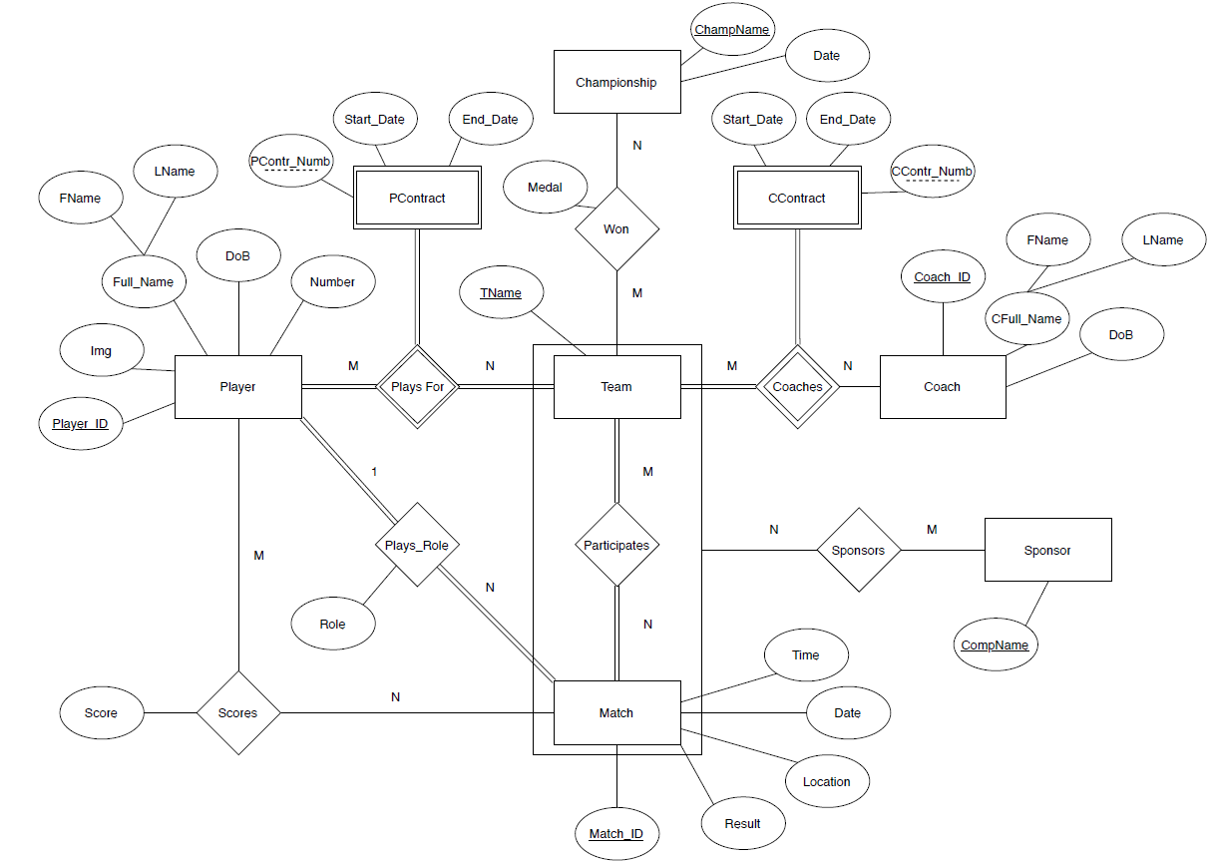

# **7. ER-Model Mapping to Database Relational Schema**

Player (PlayerID, PFName, PLName, DoB,Img)

Team (TName)

Championship (ChamName, Date)

Coach (CoachID, CFname, CLName, DoB)

Match (MatchID, Time, Date, Location, Result)

Sponsor (CompName)

Player_Team_Contract(**PlayerID**, **TName,** PContr_Numb, Start_Date, End_Date, Number)

Coach_Team_Contract(**Coach_ID**,**TName,**CContr_Numb, Start_Date,End_Date)

Player_PlaysRole_in_Match (**PlayerID, MatchID**, Role)

Player_Scores_in_Match (**PlayerID, MatchID,** Score)

Team_Wins_Championship (**TName, ChampName**, Medal)

Team_Participates_in_Match (**TName, MatchID**)

Sponsor_Sponsors_Match (**CompName,TName,MatchID**)

# **8. Normalization**

a. First Normal Form

1. There is no composite key and multivalued attributes. Full Name has been divided in FName and LName. All the attributes are atomic.

b. Second Normal Form

1. It is already in First Normal form. All the attributes can be uniquely defined by their primary keys. With PlayerID we can get a unique PFName, PLName, Dob and image. There is no partial dependency among any relation. MatchID can determine Time, Date, Location, Result of that match. The same is for Sponsors and Championship.

c. Third Normal Form

1. It is already in Second Normal Form. All the nonprime keys are dependant on their primary keys. There are no transitive dependencies. So, it is in third normal form.

# **9. Determining Data Types (Domain) and Constraints**

PlayerID, MatchID and CoachID are INT data type – they are auto incremented, so we use integers.

PFName and PLName, CoachFName and CoachLName VARCHAR (30) – we put first and last names (characters), make a limit of 30 chars and variable length to save disc space, cannot be NULL since this info is important.

Player and Coach DOB, ChampDate and MatchTimeDate are DATE data type which represent a day and time (in case of Match) of an event.

Img VARCHAR (200) – we will put URL to the photo of a player, make restriction on 200 char to save disk space.

TeamName, ChampionshipName, Location VARCHAR (30), and CompanyName VARCHAR (40) – they are primary keys, make a limit of 30 and 40 chars and variable length to save disc space.

Result CHAR (5) – we use char of five since we put a result as “00-00”.

PContr_Numb and CContr_Numb INT NOT NULL – we use a contract number which is unique and has int data type.

Start_Date and End_Date of the contract – have DATE format.

Role CHAR (2) – use only two characters to identify player’s role (GK for Goalkeeper, CF for Centre forward and so forth).

Score INT – a player can score a couple times during the match.

Medal VARCHAR (6) – indicates gold or silver medal (max 6 char).

# **10. Creating Database and Tables - SQL DDL**

SOCCER TABLES.sql

# **11. Inserting Values in Tables**

INSERT DATA.sql

# **12. SQL Queries**

Soccer_Main.sql

Requests:

1. Who was team’s coach in specific year?
2. Show players who play under number 10
3. Who plays a “central forward” (‘CF’) role?
4. Players whose contract ends this year
5. Which sponsor contributed the most?
6. Which team has the biggest number of golden medals?
7. Which team has the biggest number of silver medals?
8. Which team won this championship (Europa League) the biggest number of times?
9. Show players in the age of 30+ and who plays for Barcelona
10. Show players in the age of <25
11. Show top 10 players who scored the most
12. Show the players who played for the same team more than 2 years
13. Who is the most experienced coach?
14. Show all matches in the year 2014
15. Show all matches were held on the chosen stadium
16. Show all sponsors of the team
17. Show all matches between chosen two teams and the result (?)
18. Show all matches which ended without only one goal
19. Which role a chosen player played in a match?
20. Show all matches the chosen team had